**Assignment No-2 [1]**

**Question:** SDLC Overview - Create a one-page infographic that outlines the SDLC phases (Requirements, Design, Implementation, Testing, Deployment), highlighting the importance of each phase and how they interconnect.

**Solution:**

* SDLC or the Software Development Life Cycle is a process that produces software with the highest quality and lowest cost in the shortest time possible.
* SDLC provides a well-structured flow of phases that help an organization to quickly produce high-quality software which is well-tested and ready for production use.
* **Diagram of SDLC:**

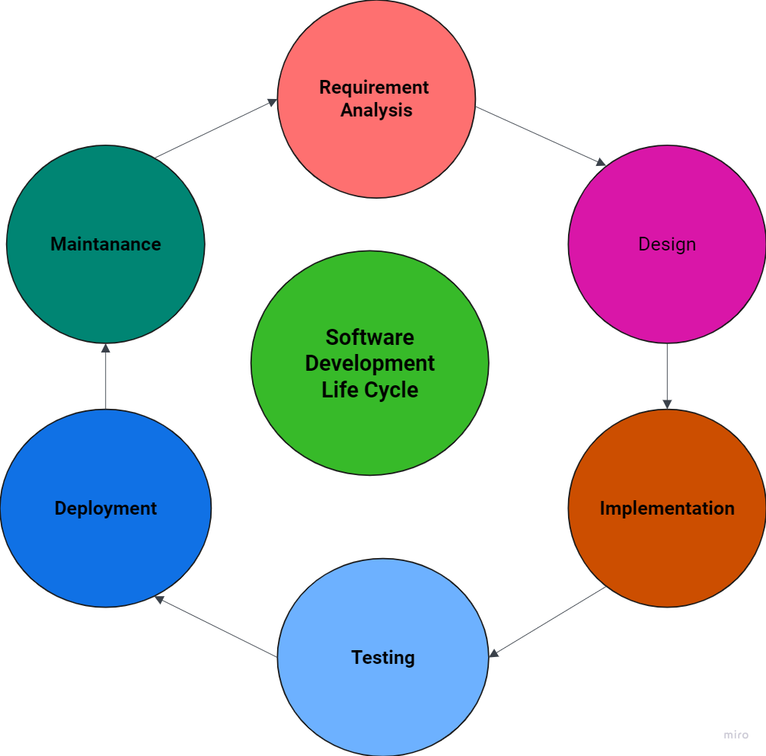

1. **Requirements Analysis:**

**Description**:

* In this stage, all the requirements for the target software are specified. These requirements get approval from customers, market analysts, and stakeholders.
* This is fulfilled by utilizing SRS (Software Requirement Specification). This is a sort of document that specifies all those things that need to be defined and created during the entire project cycle.

**Importance:**

* Captures stakeholder needs and expectations.
* Forms the foundation for design and development.

**Interconnection:**

* Directly informs the Design phase.

1. **Design:**

**Description:**

* Crafting the architecture and detailed design specifications is the primary focus of this phase.
* Designers create a plan for how the software will be structured and how its components will interact with each other.

**Importance**:

* Translating requirements into a blueprint for building the software is the key importance of this phase.
* It ensures that the software is designed in a way that meets the specified requirements and fulfills the needs of the stakeholders.

**Interconnection**:

* Guides the implementation phase.

1. **Implementation/Development:**

**Description**:

* Writing the actual code based on the design is the primary activity in this phase.
* Developers translate the design specifications into executable code, implementing the logic and functionality outlined during the design phase.

**Importance:**

* This phase is crucial as it marks the actual development of the software product.
* It transforms the conceptual design into tangible software, laying the foundation for the final product.

**Interconnection:**

* Code is built according to the design and requirements.

1. **Testing:**

**Description**:

* Verifying and validating that the software works as intended is the primary objective of the testing phase.
* Testers execute various tests, including functional, integration, system, and acceptance testing, to ensure that the software meets the specified requirements and functions correctly.

**Importance**:

* This phase is crucial for identifying and fixing bugs, ensuring the quality and functionality of the software.
* By detecting defects early in the development process, testing helps prevent issues from reaching the production environment and impacting end-users.

**Interconnection**:

* Relies on implementation, feeds back into it for corrections.

1. **Deployment:**

**Description**:

* Releasing the software to users marks the primary activity in the deployment phase.
* This involves making the software available for use in a real environment, whether it's a production server, app store, or physical devices.

**Importance**:

* The deployment phase is crucial as it makes the software available for use by end-users.
* It transitions the software from development and testing environments to a live environment where it can fulfill its intended purpose.

**Interconnection**:

* The deployment phase follows the testing phase, ensuring that the software has undergone thorough testing and is ready for release.